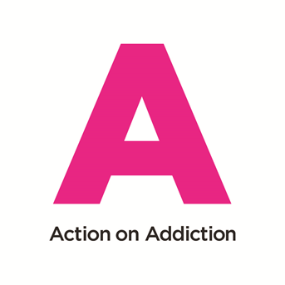
Online Course Application Form
Continuing Professional Development - The Centre for Addiction Treatment Studies (CATS)

We are delighted you are interested in one of our courses. To secure your place please complete the booking form below (one form per course) and make your payment as soon as possible by phoning the team on 01985 843740. Please send this form to: training@actiononaddiction.org.uk

Section 1: Course details

Name of course:
Course date(s):

Section 2: Personal details

Name:
Contact address:
Post code:
Contact telephone number:
Contact e-mail address:
Date of birth:

Section 3: Entry requirements

Please note: If you are applying for any CPD course with the Centre for Addiction Treatment Studies, we require all students to have some prior knowledge and experience of working in the addiction field or a related/relevant profession.

Please provide us with some details in the boxes below. These will be passed on to the course/ subject Tutor who will review all applications for their suitability. If there are any queries the course Tutor may wish to speak to you to discuss your application and level of experience:

Please list your professional qualifications (e.g. degree, diploma, award or certificate):

Please give details of your relevant work experience include the positions held, length of time in role and type of work undertaken:

Please explain why you want to attend the course and how it relates to or will benefit your current role:

What are your expectations of the course?

Please specify how you heard about the course?

Section 4: Statistical details

Nationality |  | Gender

Ethnic Origin | White | Mixed | Asian | Asian/  British | Black | Black/  British | Chinese | Other

Section 5: Learner accessibility needs

Do you have a disability/
special needs/medical
condition?

If yes, please give details

Section 6: Data Protection

All data that you provide will be stored and used by Action on Addiction under the terms laid down under the Data Protection Act 2018

We would like to keep you informed about Action on Addiction’s news and services by email including details of our courses at the Centre for Addiction Treatment Studies. Tick here if you would like to receive these emails.
You can choose to unsubscribe at any time.
Section 7: Payment details
Are you funding the cost of the course yourself: Yes No

If No, please provide details of who will be paying your course fees below so we can contact them:
Employer ☐ Placement credit ☐ Other ☐ :please state ______________

Name of organisation/person paying course fees or placement provider:
Contact details (address, telephone number, e-mail):

Section 8: Booking information

Please note places are only confirmed once full payment has been received prior to the start of the course. Please refer to our payment terms and cancellation policy on our website: www.actiononaddiction.org.uk

Places are allocated on a first come, first served basis.

All courses require a minimum number of participants to run. Courses may be cancelled if the minimum number is not reached. Please also see our cancellation policy on our website.

Section 9: Declaration

Please tick the box below to confirm your booking: | Please tick:
I confirm that I have read and understood the contents of this application form.

Returning this form: Please email the completed form to:

training@actiononaddiction.org.uk

Office Use Only
Approved by tutor |  | Registered on AoA Moodle

Action on Addiction The Centre for Addiction Treatment Studies Warminster Wiltshire BA12 8PY | T 01985 843780
Charity No 1117988 | Company No 05947481 | www.actiononaddiction.org.uk | training@actiononaddiction.org.uk

Action on Addiction For Families Centre for Addiction Treatment Studies, The Manor House, Warminster BA12 8PY 6BE | T 01985 843782
Charity No 1117988 | Company No 05947481 | www.actiononaddiction.org.uk | email: ForFamilies@actiononaddiction.org.uk

